**CSSE1001: 2018 S1 Exam**

[**UQAttic**](http://uqattic.net)

[**Other exam papers**](https://drive.google.com/open?id=0B_gnBD5zp3rqT2hrLWhvd2Rkc1U)

Please **contribute** to these documents.

If you're looking for an effective way to familiarise yourself with the course material, you can't go past collaborating with fellow students. We have laboured to put these up, and so at the very least point out where you think we are wrong!

You'll get more out of the course, you'll do better in the exam, and other students will benefit from your input as well.

To get editing permissions, visit [UQAttic.net](http://uqattic.net) and provide us with your Google Account address.

**Style.**

Type answers in blue beneath each question.

If you're unsure of your answer, highlight your answer text then hit Ctrl+Alt+M to create a comment beside the text. Once you're satisfied with the answer, click the "Resolve" button on the comment.

If you want some extra explanation from someone else on their answer, highlight the other person's answer and repeat the procedure above.

Feel free to contribute, unsure about highlighted answers 😱

1. B - (+100)

2. D - (4+5/2), (4+2.5), =6. 5 [Mathematical order is the same as in real life]

3. D

4. C

5. A - ( why it’s not ERROR??? It’s a tuple, which you can add elements to. I.e. (1, 2) + (3, 4) would evaluate to (1,2,3,4), and it works the same with strings.

6. B

7. B

8. C

9. D

10. A - (+4 ) (doubt: is it not c?) it is A (It is ‘c’, which is A) (strings add together first and then the index 2 which is the character ‘c’ being option a)

11. B - (+1) I put this in python and got B

Input returns strings (as the inputs were not converted to int)

 strings

12. C - someone pls explain, answer is c - d.get(‘key’, ‘default’) method gets a key/value. If key not found, the default value is returned else None is returned. Thanks!

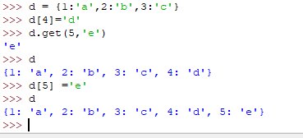

13. A - answered at 2018 sem2 help session.

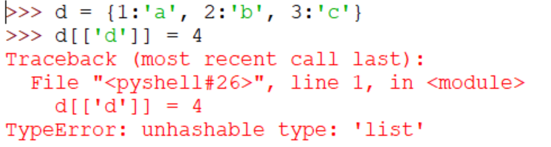  
Dictionary keys must be immutable. (such as strings or ints).

14. A - isn’t the answer d ??(+1) No, its asking for the value of a

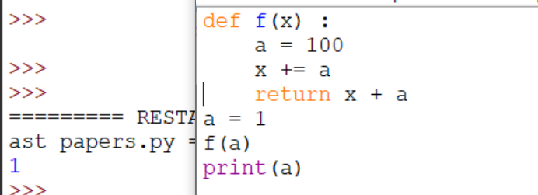

If you do it in the python shell it comes out as 201?

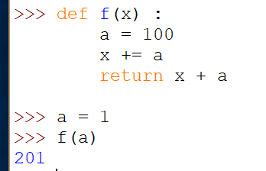

Because a = 100, then x = 100, return x + a = 200, then f(a) makes a = 1, then x += a makes x = 201? I’m genuinely not sure but I think it goes something along those lines.

If it was a = f(a), then a would equal 201. f(a) does return 201, but it’s a trick question as f(a) doesn’t affect the initial variable ‘a’.

Be careful with this question, it is asking for the value of the global variable a and not the value of f(a). a=1 so the answer is a)

That’s so cheeky (They went over this in the help session)

So, just to clarify, there’s no meaning to the ‘global variable a’ part of the question?

15. C - pls explain. :))))))))))

It is because when l.append(a) is executed x becomes [5,9,2], because x = l

Therefore when f(x, 2, 1) = [5,9,2,1]:

f(x,2,1)+ x

=[[5, 9, 2, 1] + [5, 9, 2]

= [5, 9, 2, 1, 5, 9, 2]

Why doesn’t x become [5, 9, 2, 1] if l = l + [b] is also executed right after l.append(a)?

Thought ans would be: [5, 9, 2, 1, 5, 9, 2, 1] or [5, 9, 2, 1, 5, 9]

l.append affects x even outside the function, so f(x,2,1) returns [5,9,2,1] but also changes x to [5,9,2].

If anyone is confused about this, watch the exam help session on blackboard. A tutor discusses this question

Where is this on blackboard?(<https://piazza.com/class/jwpvdcx1l0v1rq?cid=2386>) Pls help. I’m struggling to see where the extra 2 comes in

16. D - (I think it’s D, I just tried out of order and it worked) it is D you can rule out a and b straight away since you have used a for statement with a list or tuple before. C can be ruled out because why would the order matter when python iterates through it. +1

17. E - (+2) I’m pretty sure it’s B? If the user enters r = 0, the while loop terminates +1

18. D - What do they mean by constants? Like x=1? Correct

19. A - why not d? Cuz from my understanding, a class(object) means a inherits the functionality from the class object. So basically, they are the same thing? Can someone expl? An object is an instance of a class, they aren’t the same thing.

20. C - (instructor in piazza said c, which makes sense)

Reasoning for why both c & a. I believe (but don’t quote me) we accepted both during that semester as the purpose of the problem was not defined. Best answer would be c. ✅(+1)

But could A still be considered a valid answer? Is it possible to have two correct answers? Pretty sure MCQ means there’s only 1 right answer

Coding: Classes

Loading from a file: Dictionary

+But personally if it was me… i would have chosen classes in the exam

21. A

Reasons why it is A for Q21:

a: you as a programmer has set up some conditions… e.g. player health can’t be negative.

Therefore if someone tries to set your health to negative by a method call etc, this is an error that you can’t deal with locally… it’s the caller’s fault.

b: functions are stand alone… so it shouldn’t care about a previous function call

c & d: this is a reason for trying & excepting code (assuming you accept code)… not  
 raising an exception

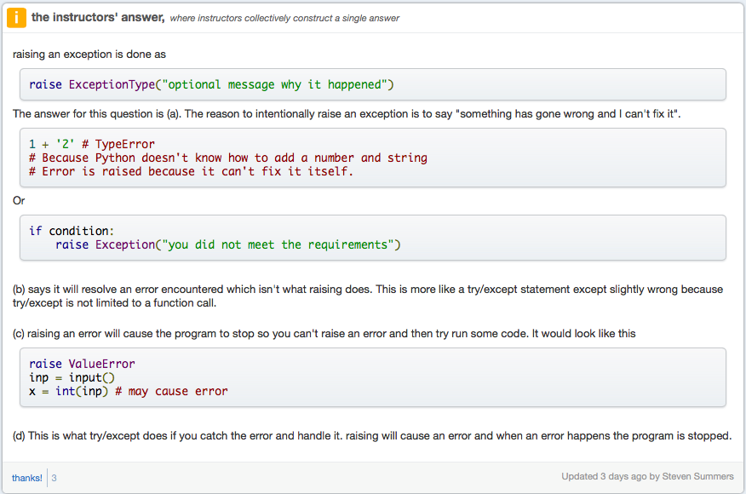 from Piazza

22. B - Explain?? The function exceptions takes two variables l and a. When the function was called l was defined as [1, 2, 3] whereas a was defined as 4. Now look at where the exceptions function was called, first statement is append 9 to l which is [1, 2, 3] the outcome of the append statement is [1, 2, 3, 9]. The second statement is a pop statement which removes an item at the given position which was given as the value of a which is 4. However, their is not a 4th position in the l list because remember that lists start at position 0. So before the raise AnException() statement can be called, python runs into an IndexError due to the pop statement. Thanks UwU

23. C - can anyone explain 23 / 24 to me please? For q23, if you follow the recursion, the list keeps getting smaller by one element (takes the 3rd element of x all the way to the end + the first element, so 2nd element is left out), and if you just keep checking the if statement(len(x) == x[0]) for the 4th iteration, len(x) = 2 and x[0] = 2, with x =[2,5]. So then x = [2,5] is returned. Does that make sense? For 24 if you do the same process you just end up with one element which just keeps looping forever. Damn - of course - thanks so much for that!!!!!!!!!!!!!!!!!!!!!!!!!!!!!!!!!!!!!!!!!!!!!!!!!!!!!!!!!! No worries

3,3,2,1,5 → 2,1,5,3 → 5,3,2 → 2,5

^^^ can someone show what numbers are leftover after each iteration for 23. I’m a little confused. Sure!

Q23)

X = [3,3,2,,5]

1st iteration: return rec(x[2:] + x[0]) = return rec([2,1,5]+ [3]) = return rec([2,1,5,3])

2nd iteration: return rec(x[2:] + x[0]) = return rec([5,3]+ [2]) = return rec([5,3,2)

3rd iteration: return rec(x[2:] + x[0]) = return rec([2]+ [5]) = return rec([2,5])

4th iteration: x = [2,5]: if len(x) = x[0]: if 2 == 2, return x

Does that help a bit?

Use me as a +1 text line: +2

^^

Thank you !!!!!

Q24)

X = [4,1,3,2,7]

1st iteration: return rec(x[2:] + x[0]) = return rec([3,2,7]+ [4]) = return rec([3,2,7,4])

2nd iteration: return rec(x[2:] + x[0]) = return rec([7,4]+ [3]) = return rec([7,4,3])

3rd iteration: return rec(x[2:] + x[0]) = return rec([3]+ [7]) = return rec([3,7])

4th iteration: return rec(x[2:] + x[0]) = return rec([ ]+ [3]) = return rec([3])

5th iteration (and every one after (infinite loop)): return rec([3]) → return rec([3])

^^ whoever did this you’re the best xoxo

24. D

25. A - Pls explain The function takes a list, and if it is greater than 1, it will split the list in half and put the two halves of the list back through itself. I.e. sum([1,2]) would then result in sum[1] + [2], which would give 3. Happy to send more help if you still don’t understand. What does :len(nums) do vs 1:len?

26. C

27. A - what if self._balance + self._over_draft = amount and as such, Why not ’ E’ is correct?

The docstring for the debit function statwes: ‘Return True if account balance and over draft limit will allow withdrawal; False otherwise.’

Therefore A is correct.

28. B - But where does account.debit() come from? There is no class called account : - account = BankAccount("123", 100, 100) (You’re creating an instance of the BankAccount class called account). Oh

29. C - why c and not d. Because each number in the scores.txt is separated by a space ‘ ‘, not a comma ‘,’

30. D - why is this d and not c? Does the float matter here? The sample answers want answers with one decimal place, i.e 1.1, 2.0, 3.0, 4.4. If it was C you would have answers of +1.1, 2, 3, 4.4. Basically, 2 != 2.0 +1 also i'm pretty sure the import will keep them as strings But wouldn’t adding floats convert everything to floats hence it wouldn’t matteru?

31. B - Why is this B and not D?Because you’re finding the average and “total” was created in ## line 2 ##. “Result” is not defined yet so D will = 0

32. D

33. D - help please.

b = B(2) makes self._x = 2

Then m1 function in class A calls on m2 from class B

M2 is self._x = 2 + y = 3, 2+3=5

Then M1 in class A gives 5*2 = 10

34. C

35. B

36. D - (who can tell me how this works?) (yeah same I don’t understand this at all lol)（How about For D(1,3) use python visualizer

self._x=4

self._y=3

For m2(2)

m2(2) = super().m2(2) + 2 =1

+ 2 = 8

super().m2(2) is the m2 in class B

(I think a lot of people see the line ‘self._x += y’ as just an ‘=’ when really its a ‘+=’)

thx！(what if the super.__init__(x) in D relates to the self._x value in B, instead of the self._x in D relating to it??????) I dont think so because all the other questions have the same and it isn’t taken into account. When calling a method in classes which inherit from each other, the classes will run the methods (if they have the same name) from the ‘highest’ class, which in this case is D. i.e. it checks if D has a method called m2, and if it doesn’t it will check the next class along (B in this case)

37. E (b and d) - C would fail with passing it `self` as the first parameter. - no the class itself is a Canvas! So both would work, since with C it would not find the method inside the class, it would automatically check the inherited class, this is the canvas

38. D - Why the doubt? This is the only one that does not call the function during the bind i.e. there are no “()”. If you look at the GameApp class at the bottom you can see that the functions are passed as arguments.

39. C (NOT TESTED ON EXAM SEM 2/2018) How do we figure the complexity questions out? Watch the help session video, the last lecture recording on blackboard. Will explain it a lot better than I can. Also youtube it: [https://www.youtube.com/results?search_query=time+complexity](https://www.youtube.com/results?search_query=time+complexity+python)

[+python](https://www.youtube.com/results?search_query=time+complexity+python)

40. B (NOT TESTED ON EXAM SEM 2/2018)

↑↑↑↑ do you mean, the rest of the questions are exactly what on exam of sem 2 on 8/11/2018?

I think it means that topic isnt tested in sem2

If you like, you can try.

Y e s t o t h e l a t t e r

O k

Thank you

It is a note for students using the exam as study during sem2 2018, do not worry about it now.

**General Question: Will the proportion of questions per topic / lecture be roughly the same as s2 2018 and s1 2018 or has the lecturer specified the final will have significant differences from years previous? The ECP’s line up pretty much the same.**

Yeah, exams are very similar in content so the questions per topic shouldn’t be too different. I wouldn’t expect to have more than 3 recursion or 2 time complexity questions for example.

**Awesome thanks. Reason I ask is because there aren’t many GUI Q’s on the previous years papers but GUI was such a big part of the course - I guess A3 was a good enough exercise in GUI understanding as they had GUI A3’s in years previous as well.**